- In Power BI, create a table with a column of order dates (at least 10 random dates from the past year) and add a calculated column using the TODAY() function to display the number of days since each order.
Hint: Use DATEDIFF([OrderDate], TODAY(), DAY).
ANSWERS:
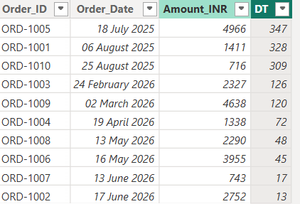
- Add a new column to your table that shows the same period last year's order date for each order using the SAMEPERIODLASTYEAR() function.
ANSWERS:
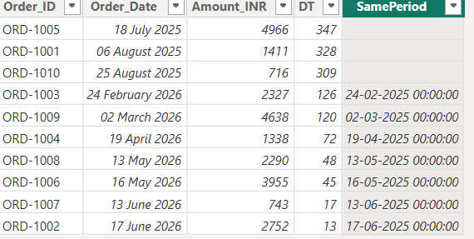

- Create a measure that uses the DATEADD() function to calculate the total sales from the previous month and display it in a card visualization.
ANSWERS:


- Use the FORMAT() function to display each order date in the format 'dd-MMM-yyyy, dddd' (e.g., '05-Jun-2023, Monday') in a new column.
ANSWERS:
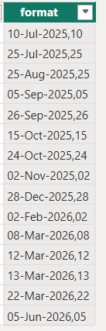

- Given a column of product codes like 'MOB1234IN', use the LEFT() and RIGHT() functions to extract the first three characters (category code) and the last two characters (region code) into separate columns.
Constraint: Do not use any custom M code — only DAX functions.
ANSWERS:
